SECTION FG

TORSIONAL VIBRATION DAMPERS.

CONTENTS

|  |  |
| --- | --- |
|  | Chapter |
| Description .. | 1 |
| Care and Handling .. | 2 |
| Removal and Fitting .. | 3 |
| Silicone Fluid Sampling | 4 |
| Special Tools .. | 5 |

CHAPTER 1

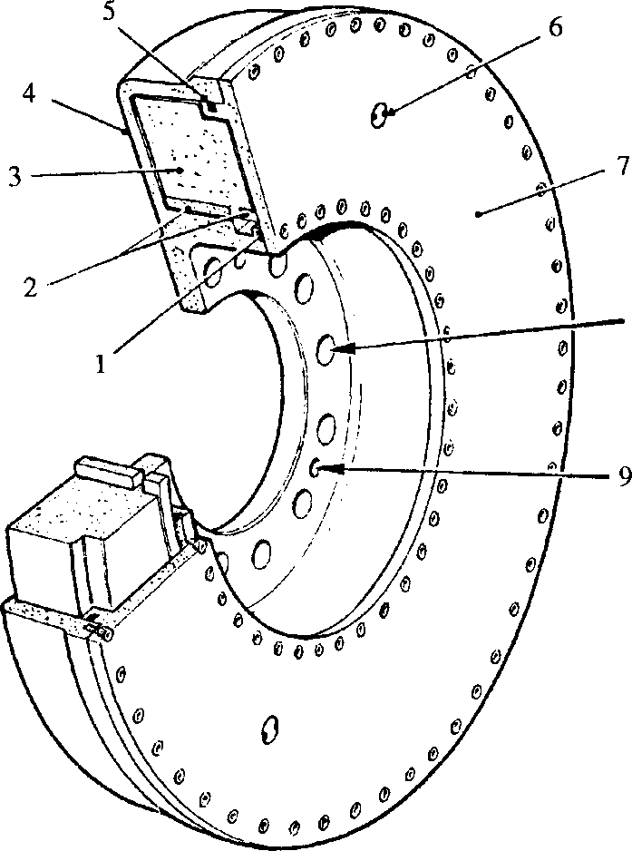DESCRIPTION.

SPD00254

Key to Numbers.

|  |  |  |  |
| --- | --- | --- | --- |
| 1. | 'O' ring | 6. | Sampling plug |
| 2. | Bearings | 7. | Cover |
| 3. | Inertia member | 8. | Mounting bolt hole |
| 4. | Housing | 9. | Tapped hole for withdrawal purposes |
| 5. | 'O' ring |  |  |

Fig FG.l Torsional vibration damper

Two viscous type torsional vibration dampers, mounted back to back on the free- end of the crankshaft and housed within the free-end cover, are fitted to minimise engine vibrations and crankshaft stresses.

Each damper consists of inertia member (3) carried in housing (4) and enclosed by cover (7) which is bolted into position and sealed by 'O' rings (1) and (5). The clearance between the inertia member and the housing is filled with silicone fluid of high viscosity. As the operational life of the damper is dependent upon the condition of the silicone fluid, plugs (6) are fitted in the cover to enable samples of the fluid to be taken for analysis.

1. During normal operation ie, at non-critical speeds, both the housing and inertia member revolve at the same speed. At a critical speed, the crankshaft vibrates and the housing takes up the vibratory motion of the crankshaft. The inertia member however, tends to revolve uniformly; relative motion therefore occurs between the housing and inertia member, and causes the film of viscous fluid in the clearances to be sheared, thereby creating opposing shear forces which damp out the vibration.

CARE AND HANDLING.

1 2 3 4 5

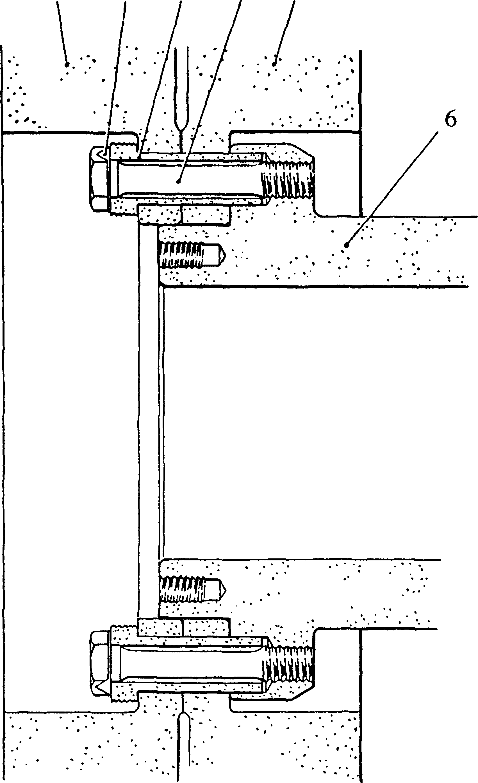

SPD00261

Key to Numbers.

1. Outer damper
2. Locking plate
3. Driving dowel
4. Bolt
5. Inner damper
6. Crankshaft

Fig. FG.2 Method of mounting dampers to crankshaft

The clearance between the inertia member and the damper housing and cover is very small and for this reason every care must be exercised when handling the damper. It must be appreciated that denting or other damage to the housing or cover will affect operation by forcing the housing against the inertia member thus preventing its movement.

2.1

If a damper is dropped accidentally or otherwise dented or damaged, a replacement damper must be fitted and the damaged one returned to our Works, or to the Maker’s or their local licensee/agent for testing.

2.2

When the damper is removed from the crankshaft, it should not be stood on its end. It should be placed flat on two pieces of wood.

2.3

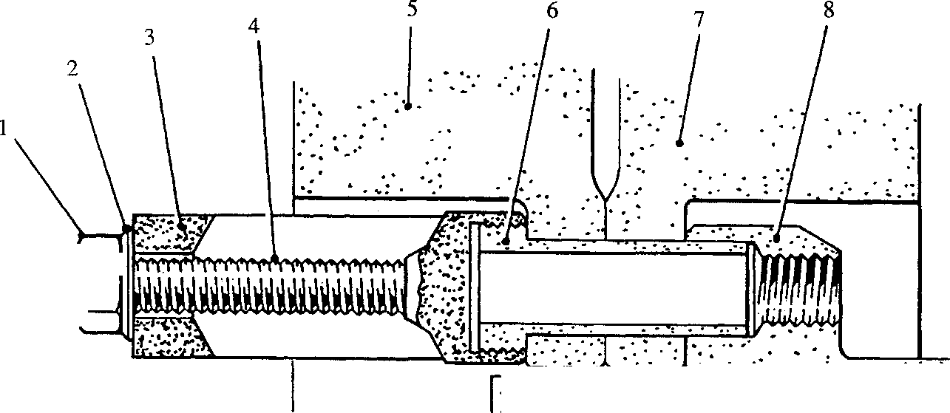Fig. FG.3 C Removing drive dowels

i—(Tfl <

mMa

SPD00255

Key to Numbers.

1. Nut
2. Washer
3. Extractor body
4. Extractor stud
5. Outer damper
6. Driving dowel
7. Inner damper
8. Crankshaft
9. If, during the service life of the engine, general vibrations appear to increase at any point in the speed range, contact must be made immediately with our Service Department giving particulars of such vibrations and speeds or speed ranges at which they occur.

CAUTION THE ENGINE MUST NOT BE OPERATED WITHOUT THE DAMPERS FITTED, OTHERWISE THERE IS A RISK OF CRANKSHAFT FAILURE.

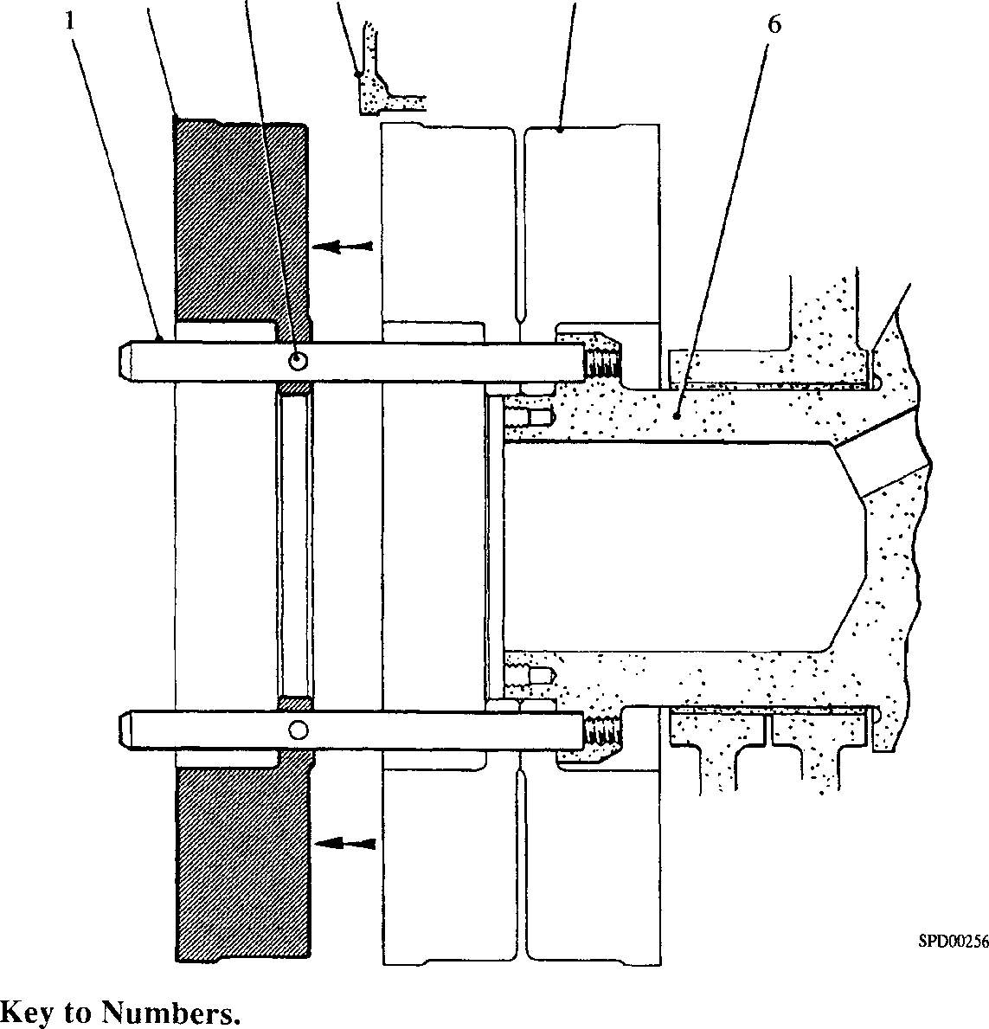

1. Locating peg
2. Free-end cover
3. Inner damper
4. Crankshaft
5. Outer damper
6. Hole for tightening bar

Fig FG.4 Damper removal

TO REMOVE AND FIT.

NOTE All joints and ’O’ rings must befitted dry.

* 1. Remove the free-end drive and drive pulley.
  2. Release and withdraw the free-end stubshaft oil seal (Section FF).
  3. Release securing nuts and remove free-end cover plate.
  4. Bend back all locking plate tabs (2)(Fig FG.2).
  5. Bar the crankshaft round to place any two damper securing bolts (4) in the horizontal, remove the two bolts and withdraw hollow dowels (6)(Fig FG.3) using the extractor tool as follows:
     1. Screw extractor stud (4) on to the threaded portion of dowel (6), flats are machined on the stud to assist tightening.
     2. Place extractor body (3) over the stud and locate against the damper flange; the body is cut away to clear the damper and stubshaft. Fit washer (2) and nut

1. .
   * 1. Holding extractor body (3) against rotation, tighten nut (1) to withdraw the dowel from the crankshaft flange and damper. Remove the extractor tool complete with dowel.
     2. Screw locating pegs (l)(Fig FG.4) into the crankshaft and tighten securely. Holes (3) to take a [1]/s in diameter bar, are provided in the pegs.
     3. Remove remaining bolts and hollow dowels securing the dampers to the crankshaft flange.
   1. Using three M16 jacking screws in the tapped holes in the damper flange, jack the outer damper off the crankshaft spigot and slide along the locating pegs until it is just clear of the free-end cover.
   2. Fit damper lifting gear (Fig FG.5), tightening bolts (3) to ensure that strap (4) securely grips the periphery of the damper.

NOTE The damper periphery is stepped and pads are fitted to the strap to compensate. It is imperative that the strap is fitted the correct way round.

* 1. Fit lifting shackle (2) together with a suitable sling (1), take the weight of the damper, slide clear of the locating pegs and lift away.
  2. Jack the inner damper off the crankshaft and remove as described above.
  3. Remove the locating pegs from the crankshaft.

To Fit Existing Dampers.

Rotate crankshaft to position the 'O' mark (Fig FG6) stamped on the outer face of the flange in the vertical position.

3.11

3.12

3.13

Screw locating pegs (l)(Fig FG4) into the crankshaft flange and tighten securely.

With the 'O' mark (Fig FG6) stamped on the outer face of the inner damper flange in the vertical position, fit lifting strap, to the damper (see Fig FG5).

LIMITED RIGHTS LEGEND

USE, DUPLICATION OR DISCLOSURE OF THIS INFORMATION WHICH IS THE PROPERTY OF GEC ALSTHOM DIESELS LIMITED BY THE U.S. GOVERNMENT OR BOLLINGER IS SUBJECT TO THE RESTRICTIONS SET FORTH IN DOD FAR SUPP 252.227-7013 (a) 15.

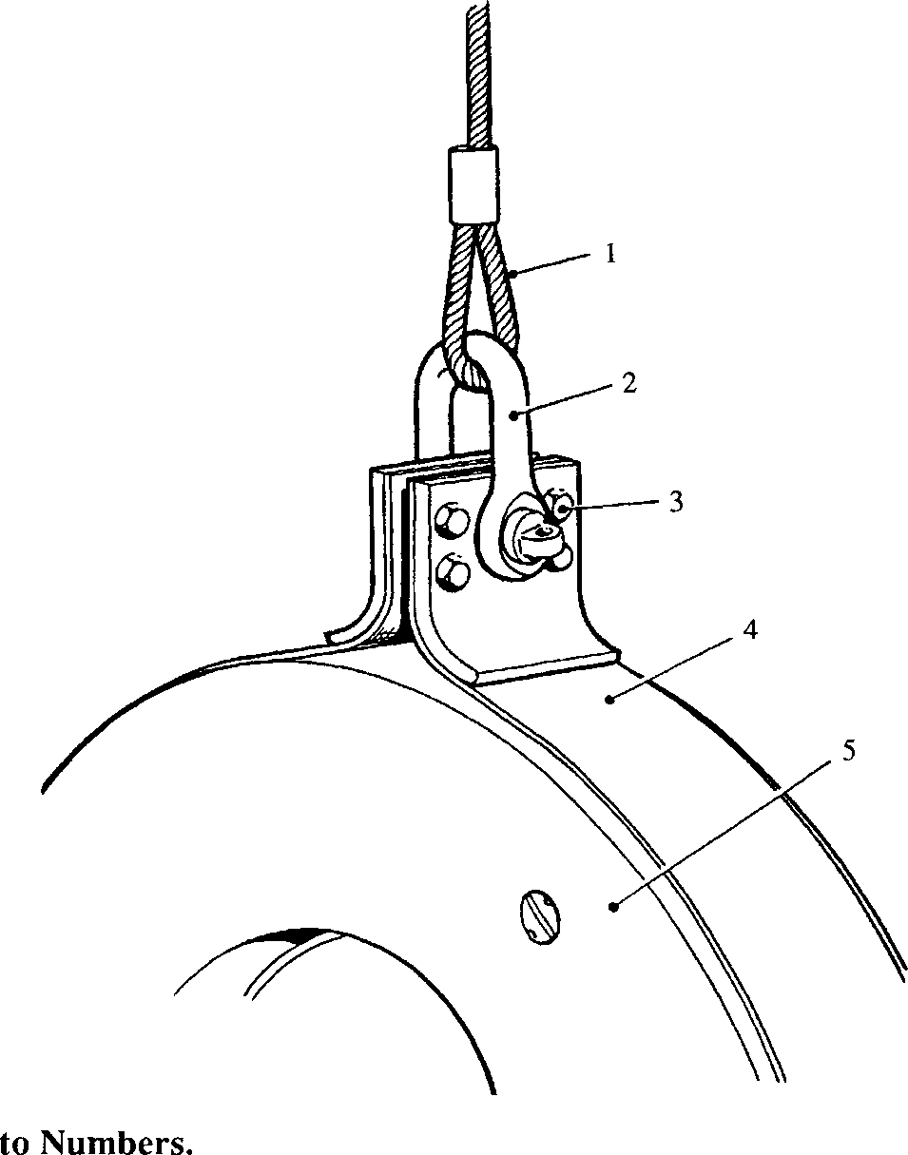

1. Lifting strap
2. Torsional vibration damper

Key

SPD00259

Key to Numbers.

1. 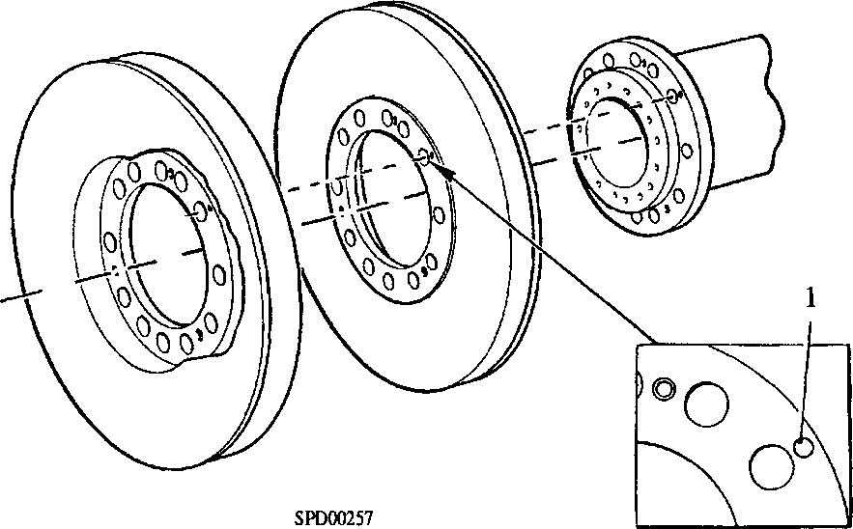Alignment 'O' mark

Fig FG.6 Alignment marking of crankshaft and dampers

1. Remove the locating pegs and fit dowels (3)(Fig FG.2). Fit locking plates (2) and bolts (4). Tighten the bolts to the torque loading quoted in Section CE, and bend up the locking plate tabs.
2. Fit the free-end cover plate and stub shaft oil seal (Section FF).
3. Fit free-end drive pulley and drive.

Replacement Damper(s).

1. If it is required to replace one or both dampers as a result of silicone fluid deterioration or damper damage, it is necessary to check the 'run-out' of each new damper before it is finally fitted to the engine. This 'run-out' must not exceed 0.005 in (0.13 mm).
2. To check and fit a new damper, proceed as follows:-
3. Remove the free-end cover (Section FH).
4. Chalk mark the upper flange face of the crankshaft to indicate position of 'O' mark on crankshaft flange.
5. If replacing the inner damper, fit the new damper to the crankshaft ensuring that the bolted cover faces towards the engine; secure with three standard M20 setscrews and plain washers.
6. With a micrometer dial indicator mounted off the machined face of the crankcase (Fig FG.7), rotate the crankshaft and record the peripheral 'run-out' of the damper at diagonally opposed points. If 'run-out' is greater than 0.005 in (0.13 mm), move the damper on the crankshaft in a clockwise direction through two holes and check 'run- out' again. Continue this procedure until 'run-out' is within limits stated. ’O' mark the outer flange of the damper to align with the 'O' mark on the crankshaft flange.
7. If replacing the outer damper, first, fit the existing inner damper to the crankshaft ensuring that the 'O' marks align, then fit the new outer damper. Secure the dampers to the crankshaft with three temporary M20 setscrews and plain washers.
8. Check and obtain desired 'run-out' of outer damper as instructed in paragraph 3.27 above. 'O' mark damper flange to align with 'O' marks on inner damper and crankshaft flange.

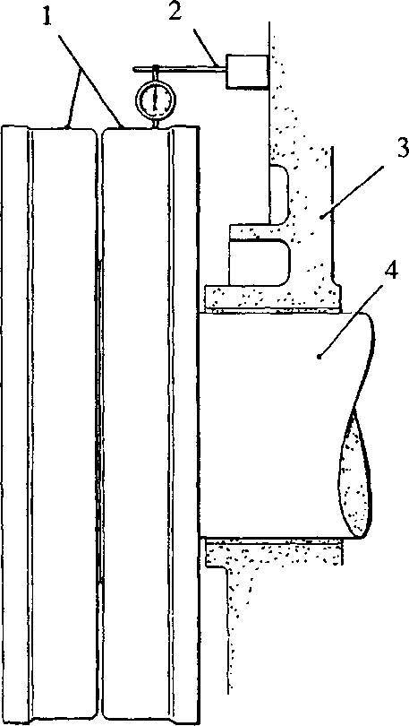

SPD00260

Key to Numbers.

1. Torsional vibration dampers 3. Crankcase
2. Micrometer dial indicator 4. Crankshaft

Fig FG.7 Checking damper 'run-out'

Remove dampers from crankshaft, refit free-end cover, and finally fit and dampers as instructed for 'Existing Damper(s)'.

3.30

secure

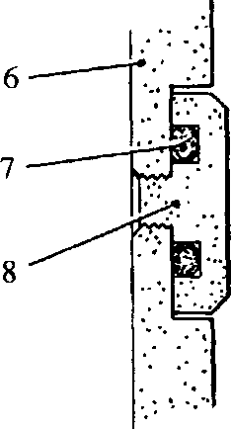SILICONE FLUID SAMPLING

1 2 3 4 5

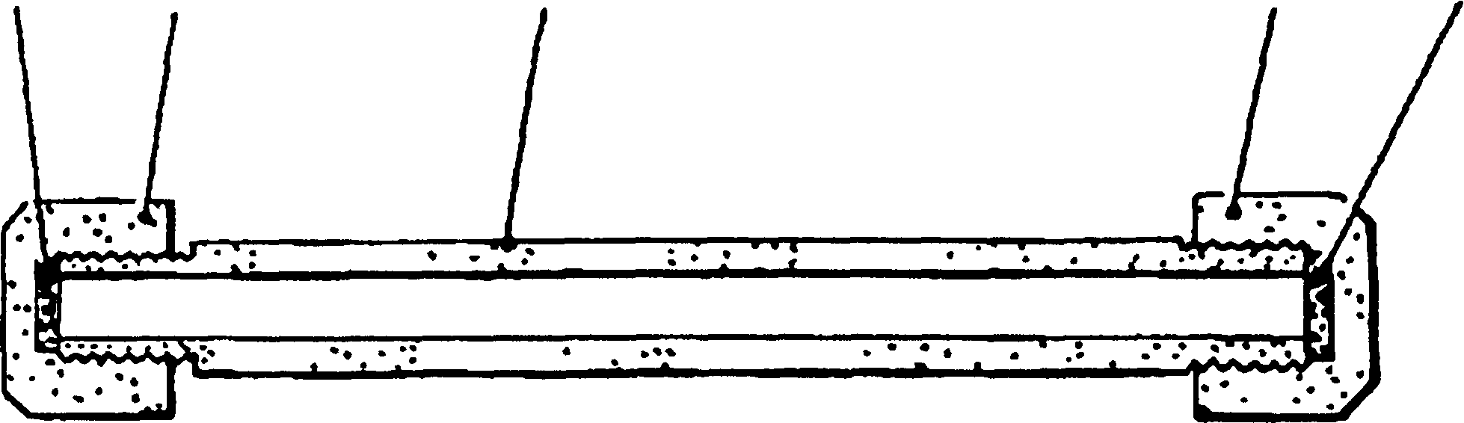

SPD00258

Key to Numbers.

1. Neoprene washer
2. Neoprene washer
3. Damper cover
4. 'O' ring seal
5. Sampling plug
6. 5/i6 in BSF cap nut
7. Sample container body
8. Vs in BSF cap nut

Fig FG.8 Silicone sample container and arrangement of damper plug

* 1. A silicone fluid sample should be taken every 6000 hours for detailed examination and report. Dependent upon analysis report, up to five samples may be taken after which the damper must be reconditioned.
  2. The sample container must be suitably labelled to show engine type and number, damper serial number, and number of hours operation. The damper serial number is stamped on the cover near the warning plate.
  3. The sample container should be forwarded to

HOLSET ENGINEERING CO. LTD.,

TURNBRIDGE,

HUDDERSFIELD, or to their local agent/licensee.

* 1. The method of taking a fluid sample is as follows and must be observed most carefully:

1. 1 Remove the dampers from the crankshaft (Chapter 3) and wipe clean.
2. Prepare sample container, (Fig FG.8), by removing cap nuts (2) and (4), and neoprene washers (1) and (5). Take care that the inside of the sample container, washers or cap nuts to do not become contaminated with engine oil or other substances.
3. Stand the damper upright with the plugs horizontal. Thoroughly clean the face of the damper and plugs of engine oil. A high evaporation rate solvent is recommended to avoid contamination.
4. Using a flat ended punch, drive cover material, locking one of the plugs, out of the plug slot. Using special spanner remove one of the damper plugs.
5. Screw the larger threaded end(3/s in BSF) of sample container (3) into the damper.

NOTE The container will only engage with the damper by approximately two full threads. This is sufficient to allow sampling without leakage. DO NOT attempt to overtighten the container into the damper as this may result in damage to the damper.

1. As soon as the silicone fluid reaches the open end of the sample container (this may take up to one hour), fit cap nut (2) and neoprene washer (1).

4.4 7 Unscrew sample container, refit screwed plug (8) ensuring that 'O' ring seal

1. is positioned correctly in its groove. Seal the sample container by fitting

cap nut (4) and neoprene washer (5).

4.4 8 Tighten screwed plug (8) to 25 lbf.ft (3.46 kgf.m) torque and lock in position

using a centre or flat ended punch to spread cover material into the plug slot.

CHAPTER 5

SPECIAL TOOLS

The following special tools are sufficient for carrying out all general maintenance, dismantling, overhaul and assembly operations on the crankshaft as detailed in this section.

NOTE These tools are only shown in the Illustrated Parts List if they if they have been ordered as part of the contract.

|  |  |  |
| --- | --- | --- |
| DESCRIPTION | PART NO | USE |
| Extractor tool | Y3J70304 | To remove hollow driving dowels |
| Locating pegs | Y3J70433 | To support dampers during removal and  fitting |
| Lifting gear | YJ70360B | For lifting dampers |
| Damper sample container | 43343/A/20/4 | For collecting damper fluid sample. |
| Special spanner | Y3J72812 | For removal of damper plugs |

1. Strap clamping bolts

   Fig FG.5 Method of lifting damper

   With the damper bolted-cover facing towards the engine, lift the damper on to the locating pegs. Ensuring that the ’O’ marks align, slide the damper along the locating pegs as close as possible to the free-end cover. Remove the lifting gear.

   Slide the damper along the locating pegs and on to the crankshaft spigot. It may be necessary to force the damper on to the crankshaft. This should be done with the aid of three standard M20 setscrews and plain washers, taking care to keep the damper square to the crankshaft.

   With the 'O' mark on the inner face of the outer damper flange in the vertical position, fit the lifting gear to the damper.

   With the damper bolted cover facing away from the engine, lift the damper on to the locating pegs. Ensuring that the 'O' marks align, slide the damper along the locating pegs as close as possible to the free-end cover. Remove the lifting gear.

   Fit the damper to the crankshaft spigot as described in operation 5 above.